**Solo project proposal**

**By Si Chen**

It is a project about designing a online shop web to manage products posting/editing / purchasing and shopping card management by users. The main functions of this online shopping platform are listed:

1. Authentication and Authorization:

People need to register user account and login to manage their products posting, purchasing and shopping cart management.

1. Display:

Both general user sand authorized users can navigate to main page to see the products listed, which should be the main page of this platform. Each product posted is show in a card including title, image, price details. The navbar on top should include login and registration buttons.

1. Login page:

The login button navigates to login page which includes username, password. If any invalidate input, it will show. If passed, it will route to main page with authorization. This page also has goback/cancel and registration buttons routing to general main page without authorization and registration page respectively.

1. Registration page:

The registration button navigates to registration page which includes username, first_name, last_name, email, password and password confirmation. If any invalidate input, it will show. If passed, it will route to main page with authorization. This page also has goback/cancel and login buttons routing to general main page without authorization and login page respectively.

1. Main page /compass with login:

On this page, it also has the products list like general main page. On top of navbar, it has logout , admin and shopping cart. Logout button will route to general page. Cart button will navigate to cart page. The admin button will route to admin page will products only posted by login user. The product card displayed will contain add to cart button and details buttons which will add product to cart and route to specific product page respectively. The specific product page will display all product information and comments appended below. Any login user can add comments for each product.

1. Cart page:

It will also list all products added. For each product, it has +/- button to increase / decrease number of product. The remove button will totally remove product from cart. Also the total price of all items is calculated and updated. The cart also has the button of submit order with function connecting to online payment(Note: for this solo project, this online transaction part will not be included. This can be continued in future.).

1. Admin page:

On admin page, it will list all products posted by login user. Each product will have add to cart , edit button. The update button will navigate to update page to edit the content of product.

1. Product update page:

It looks similar with individual product page but user can edit the contents. It can also has function of delete product.

For 5, 7 and 8, they all have nav bar contains goback to main page/ logout and cart button.

Link of whole web wire frame:

https://balsamiq.cloud/sd3arjz/pmpqbbs/r57AC

**Here is the wire frame for demo:**

1. <https://share.balsamiq.com/c/k6U4wFMDMRX1WWCZy6dNhg.png>

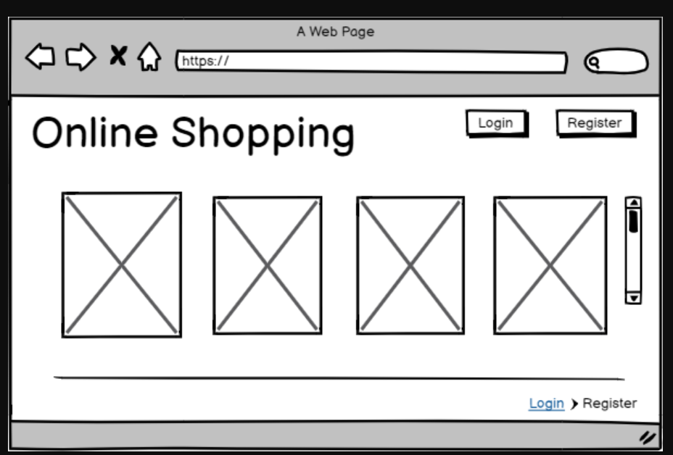

1. <https://share.balsamiq.com/c/hhmNm718fH6UXqE9unPQN7.png>

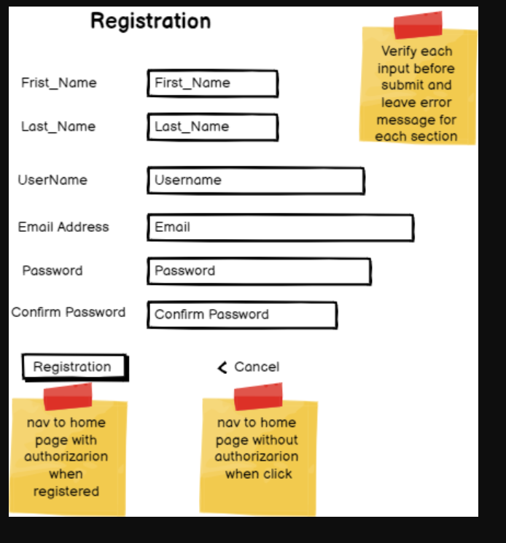

1. <https://share.balsamiq.com/c/kgSAGJn5YDuSQa6EB54qQH.png>

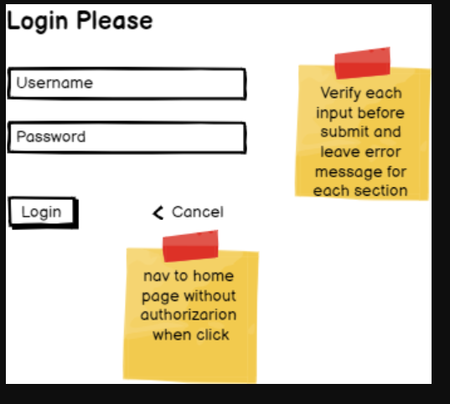

1. <https://share.balsamiq.com/c/fHc3optZUTrwr6rL3UYm5r.png>

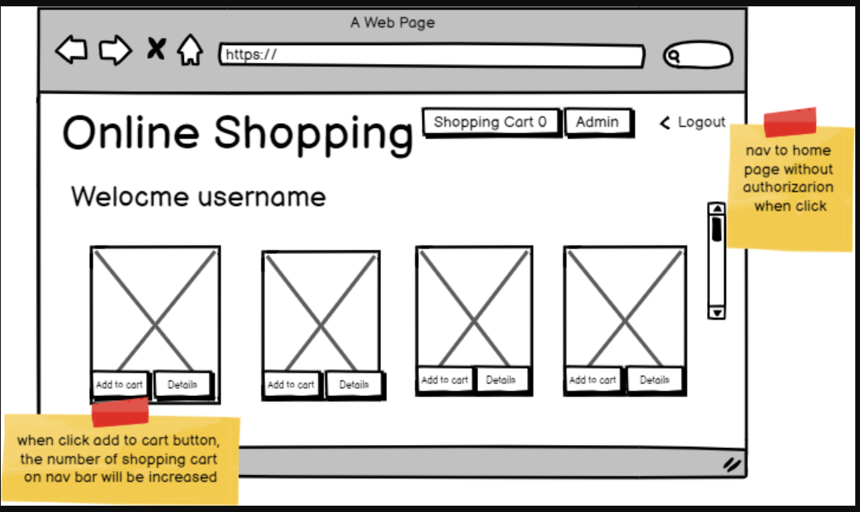

1. <https://share.balsamiq.com/c/rSacfqvewEKLwgMuxbaTpj.png>

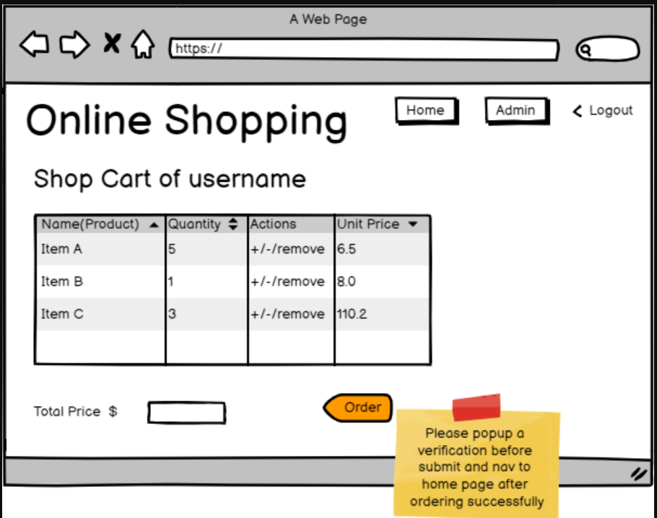

1. <https://share.balsamiq.com/c/9YVMrgxsFgSRBxhVZoxZ37.png>

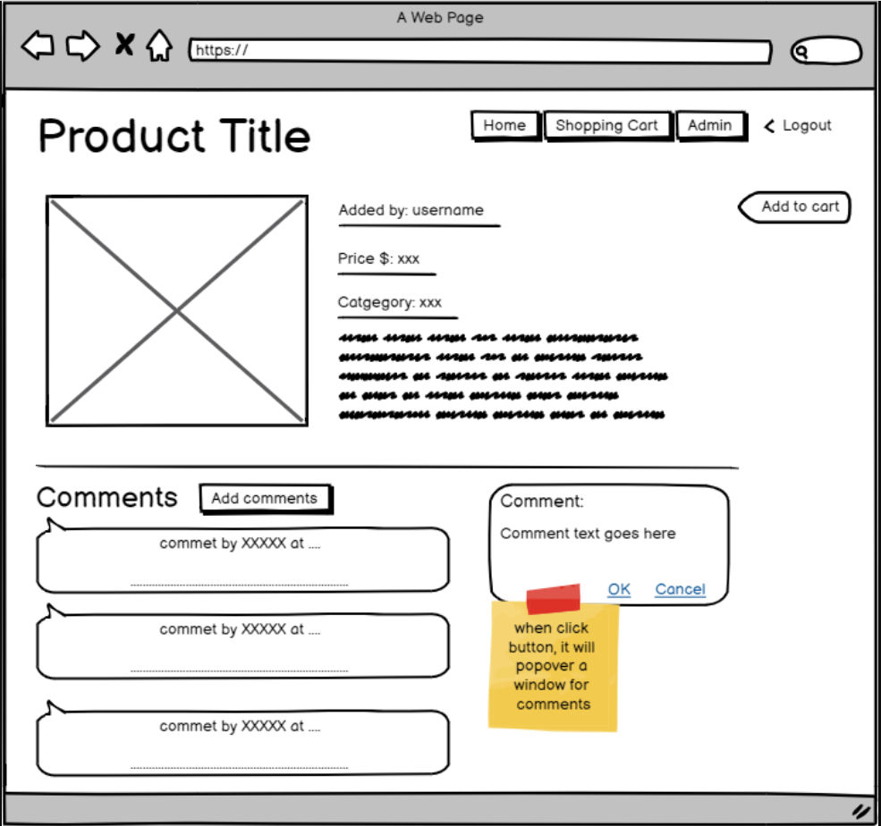

1. <https://share.balsamiq.com/c/oETsdd94zFWwkVUyGCDUxs.png>

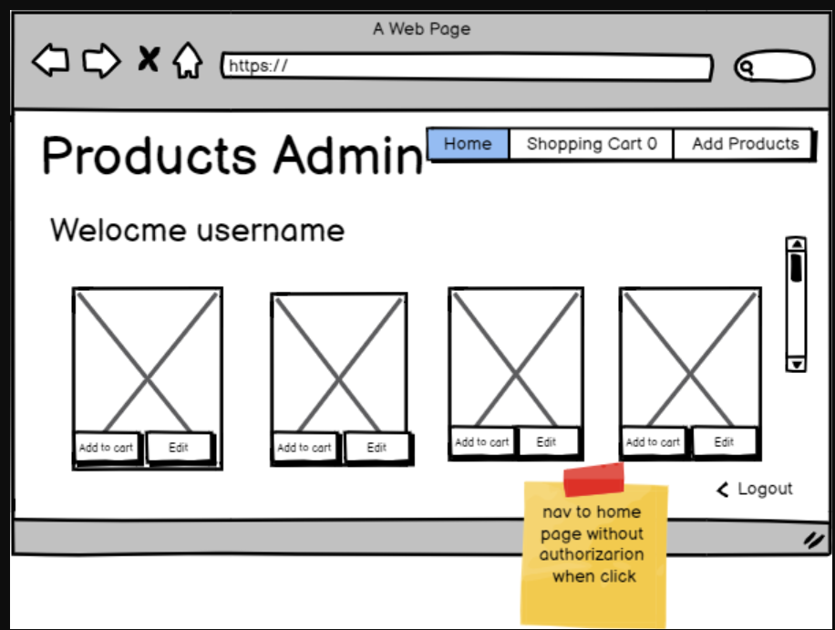

1. <https://share.balsamiq.com/c/ab3HDmHTVYBmgPo1LjZ2y5.png>

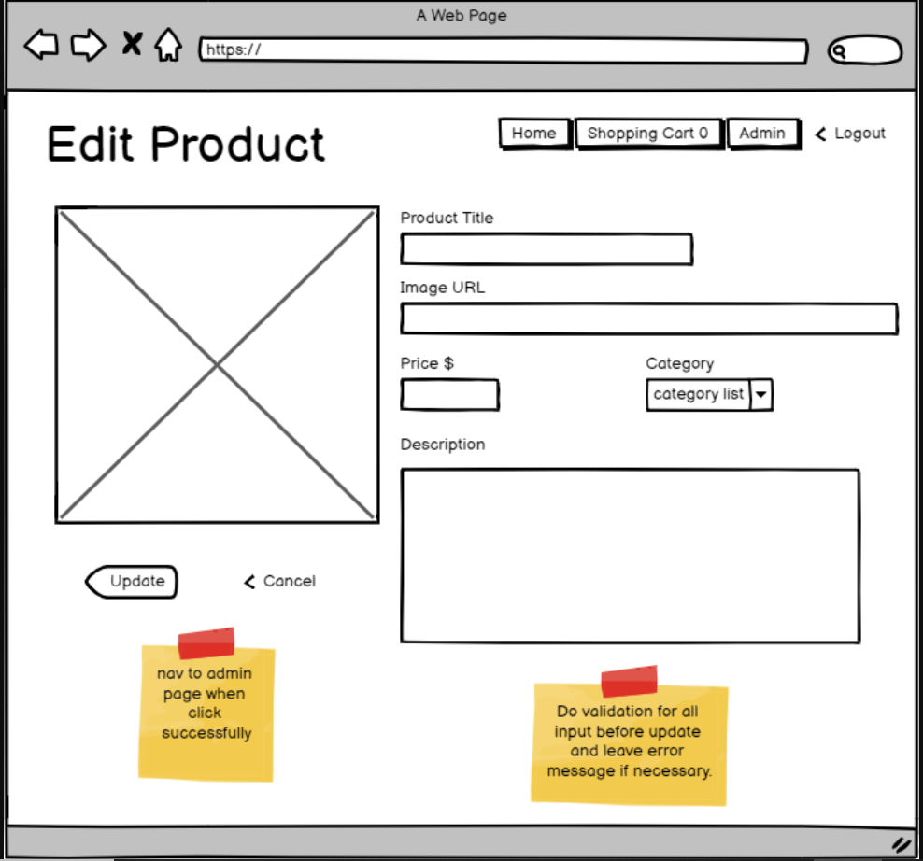

1. <https://share.balsamiq.com/c/otxXVUnbkiKB4AuGDaKwkc.png>

